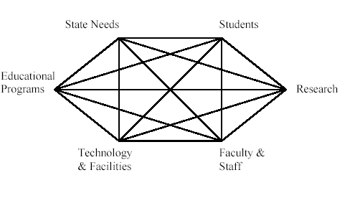
University of Alaska Board of Regents
Program Approval Summary Form
Requirements:
- 2 pages or less
- Must be a stand-alone document

MAU:
Title:
Target admission date:

How does the program relate to the Education mission of the University of Alaska and the MAU?
*Who promoted the development of the program?
*What process was followed in development of program (including internal and external consultation)
*Impact on existing programs and units across MAU and system, including GERs.

What State Needs met by this program.
*Information describing program need and why existing programs in UA system are not able to meet it.

What are the Student opportunities and outcomes? Enrollment projections?

Describe Research opportunities:

Describe Fiscal Plan for development and implementation:
*Identify funding requirement, sources and plan to generate revenue and meet identified costs to include:
- *Indirect costs to other units (e.g. GERs)
- *Faculty and Staff
- *Technology, Facilities and Equipment

